Clustering

Open Orange Application. Select File from Data.

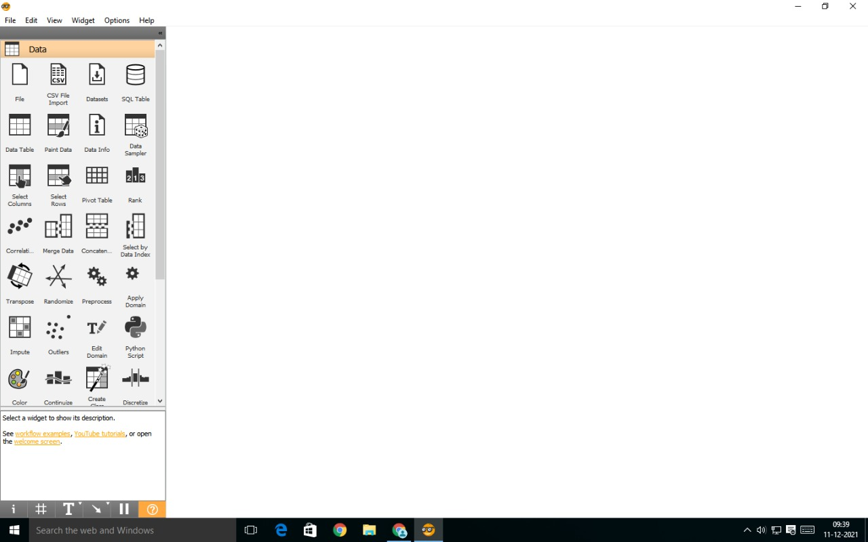

Double Click on the file appeared in the screen.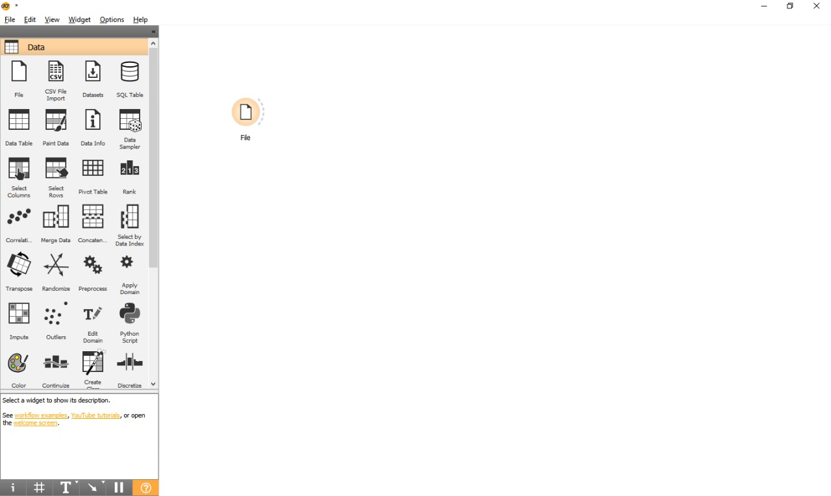

A dialogue box will appear select iris.tab and close the dialogue box.

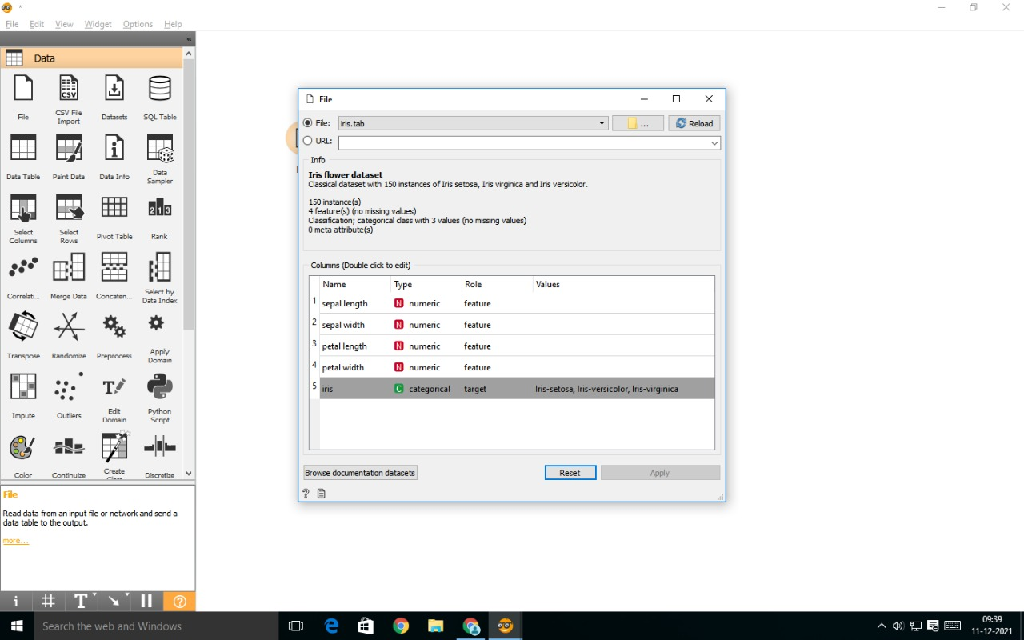

Click on the dashed line on right side of the file and drag the mouse and select Distance from the list.

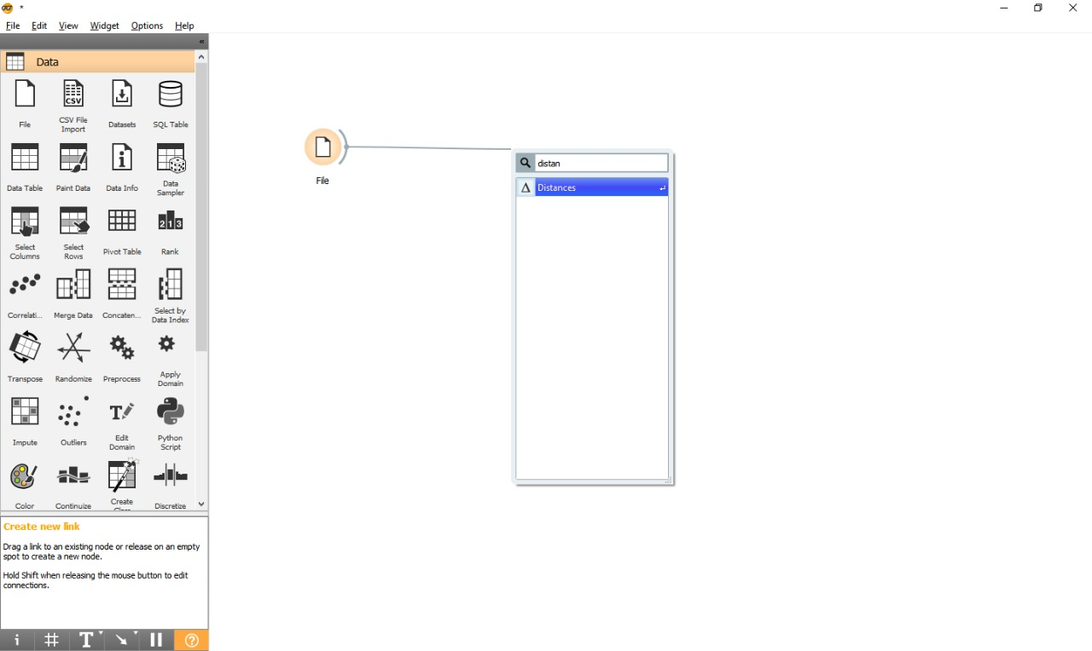

Follow the same procedure from Distance and Select Hierarchical Clustering.

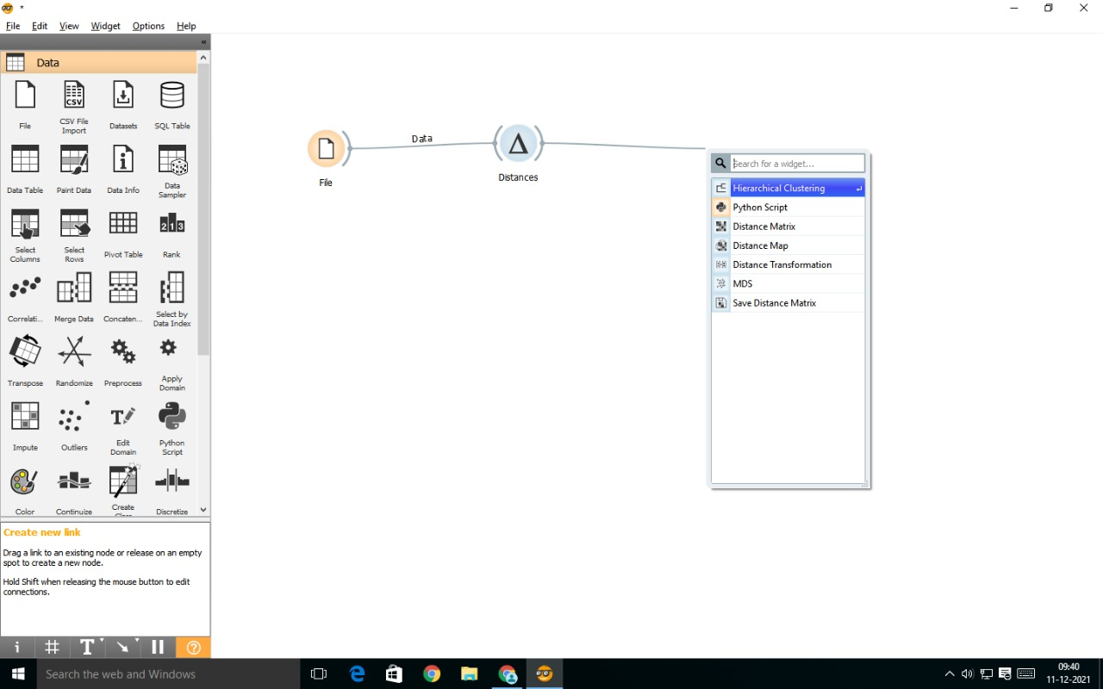

Double click on the hierarchical clustering a dialogue box appears.

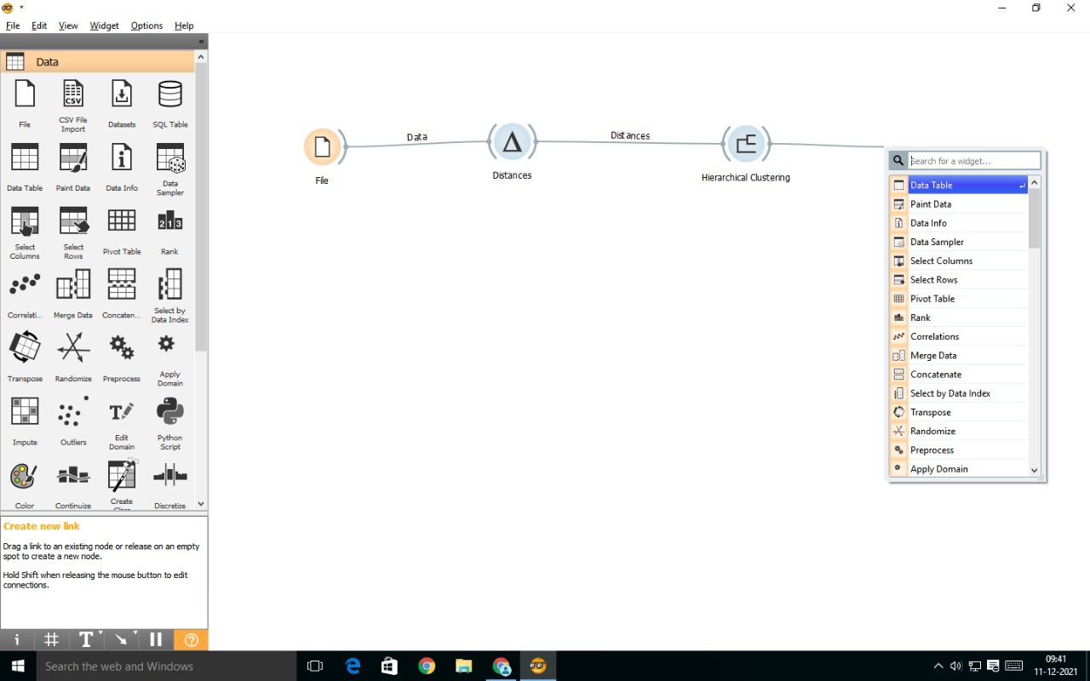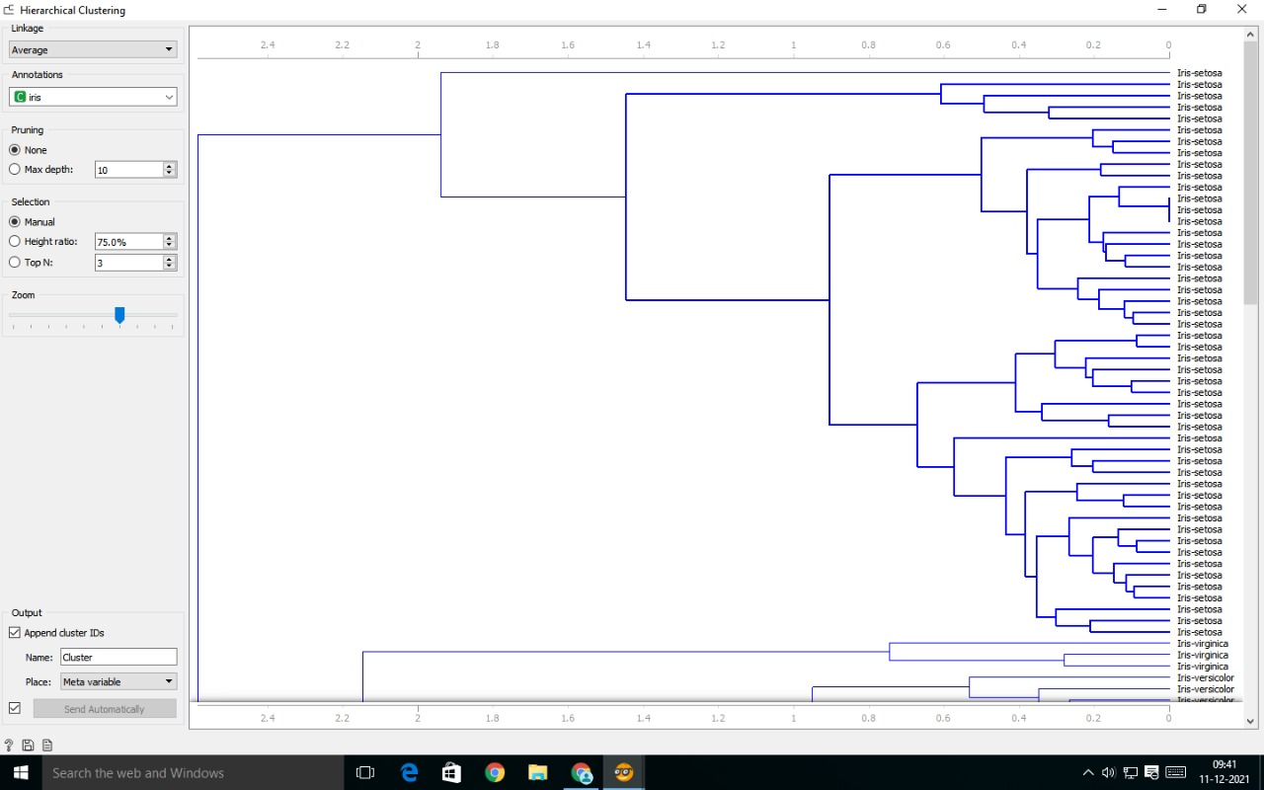

Now select the sub cluster as shown in below.

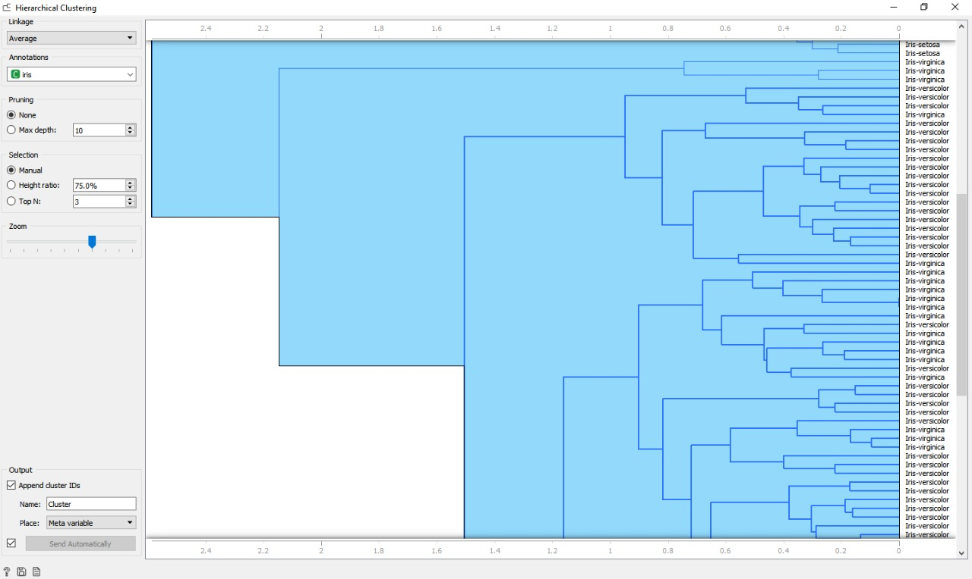

Now click on hierarchical clustering and select data table.

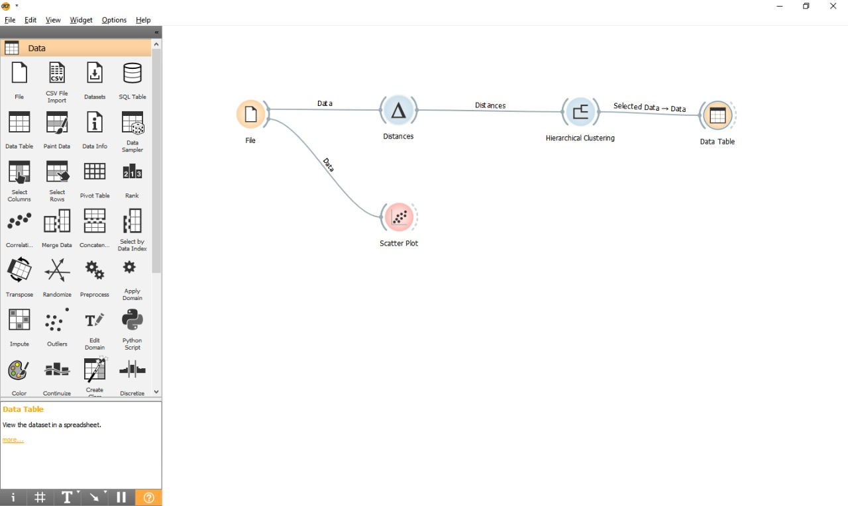

Double click on it and the following table will appear.

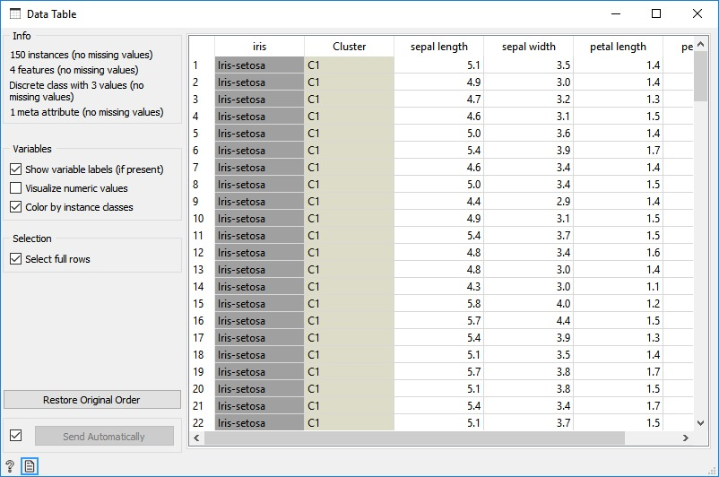

Now click on file and select Scatter plot.



By double clicking on the dialogue box the following graph will be shown.

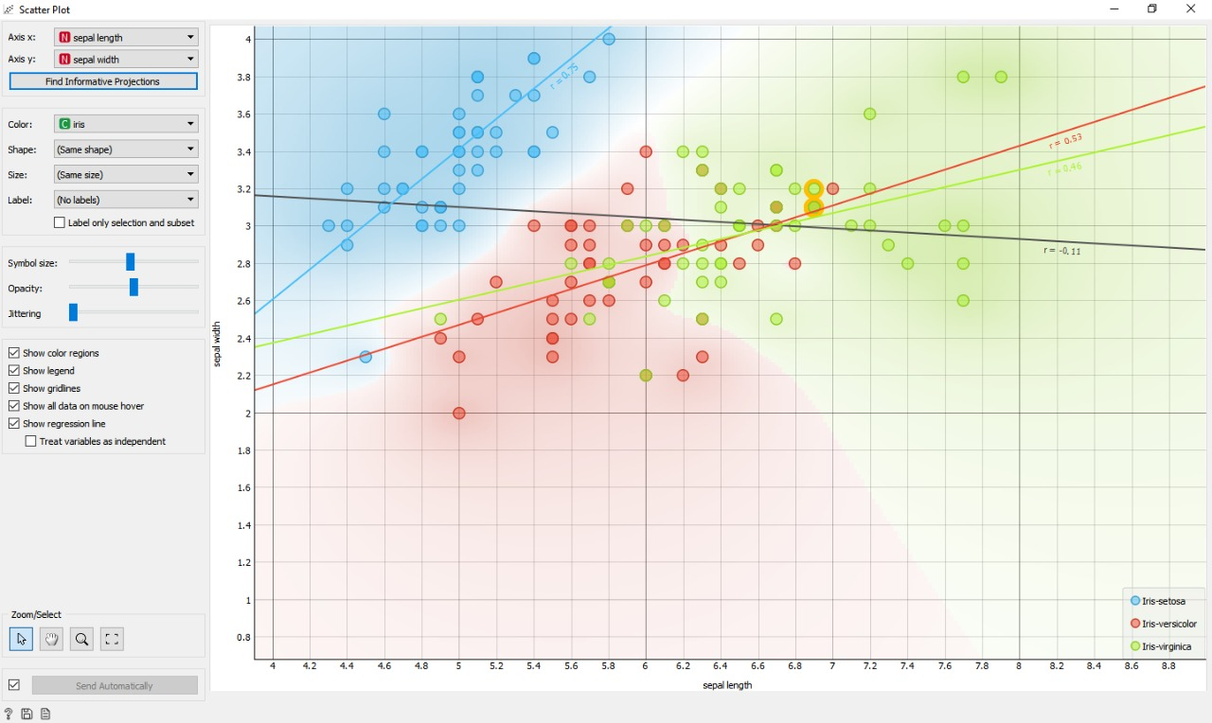

Classification.

Open Orange Application. Select File from Data. 



Double Click on the file and select zoo.tab and close it.

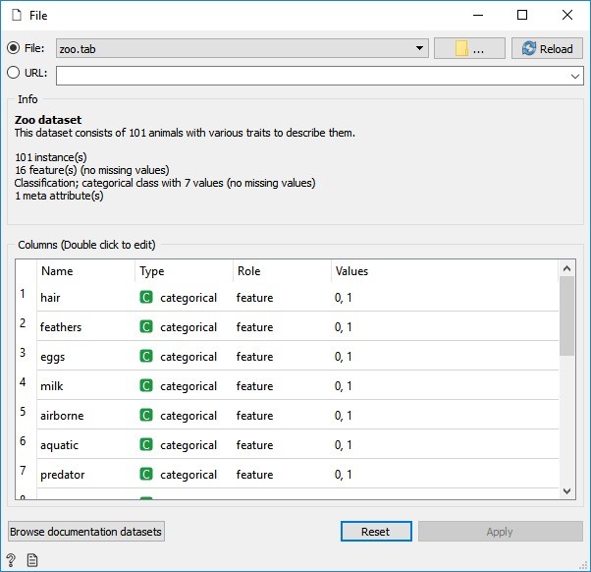

Select the file and drag the cursor and select data sampler from the list.

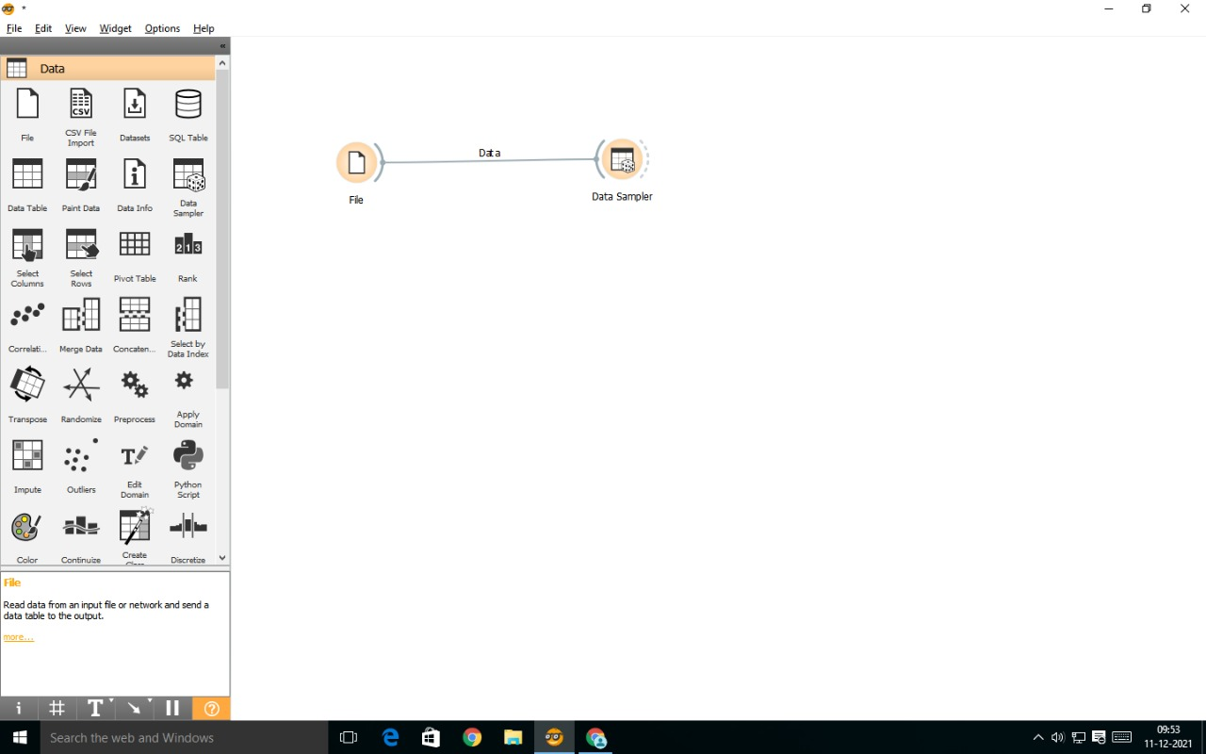

Select Naïve Bayes, Tree and Prediction from the list similar to data sampler.

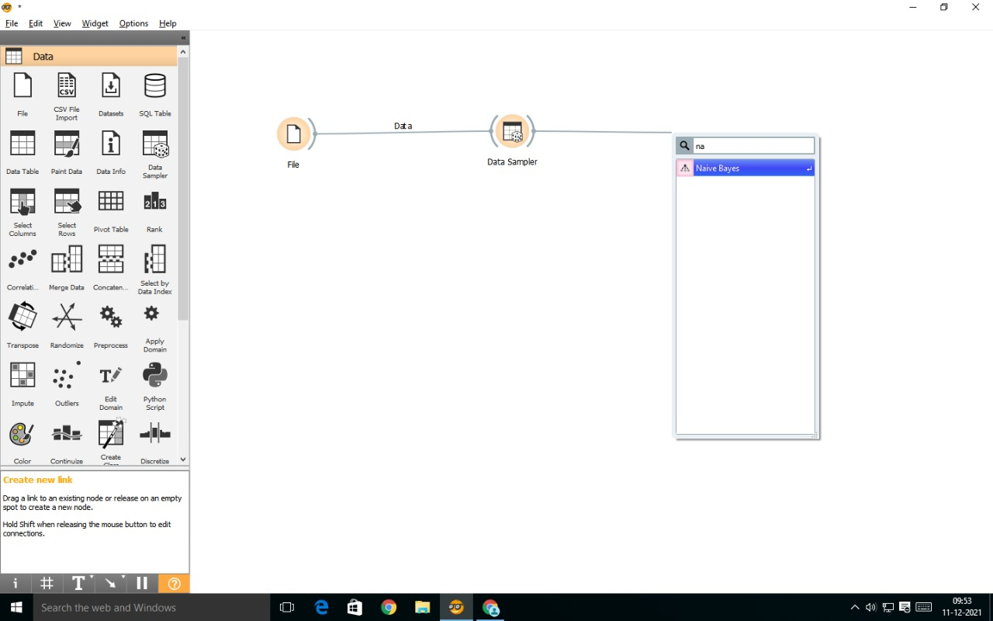

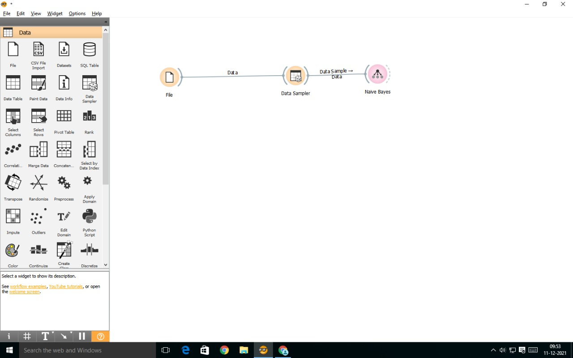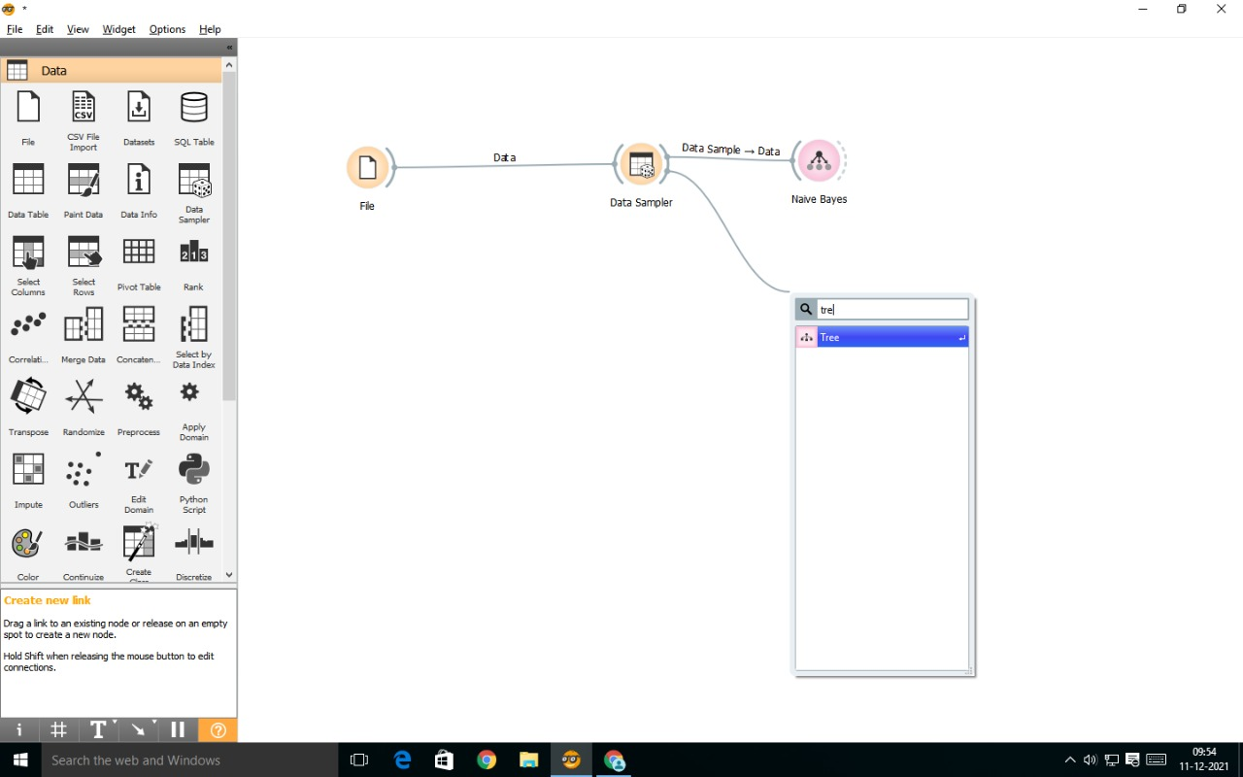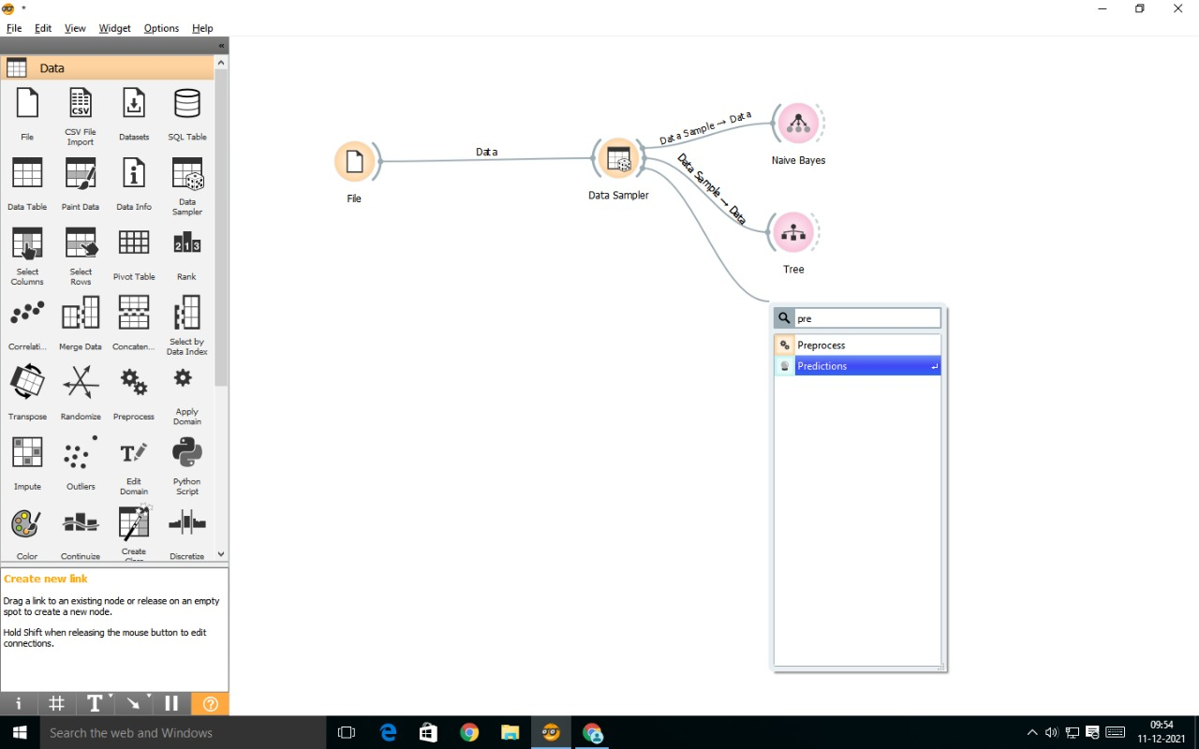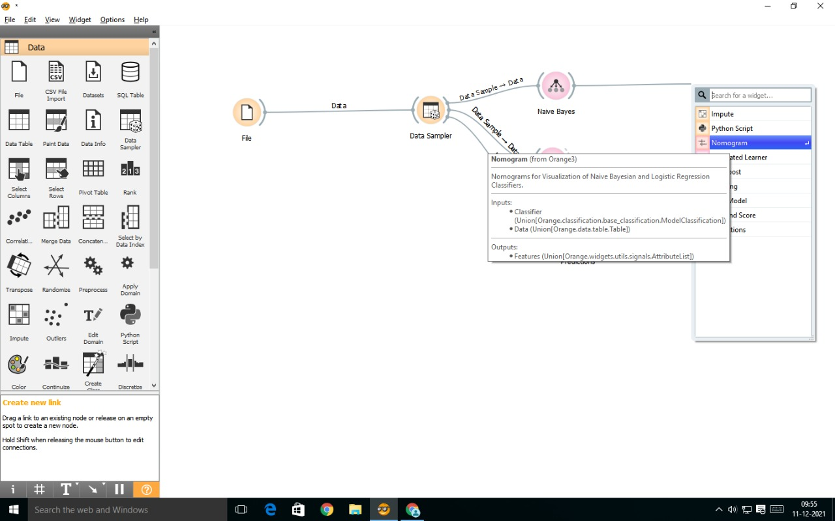

Double click on the nomogram and the following dialogue box will appear.

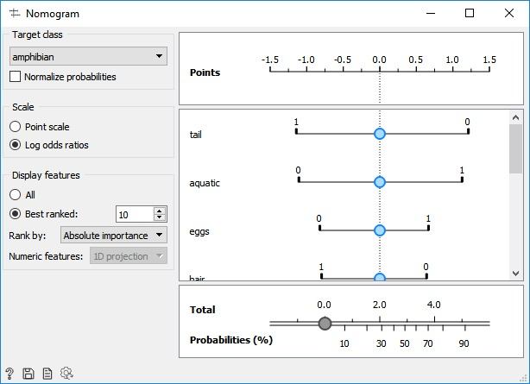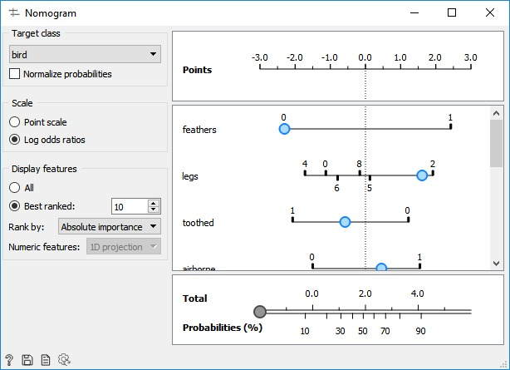

Connect Naïve Bayes and Tree with Prediction.

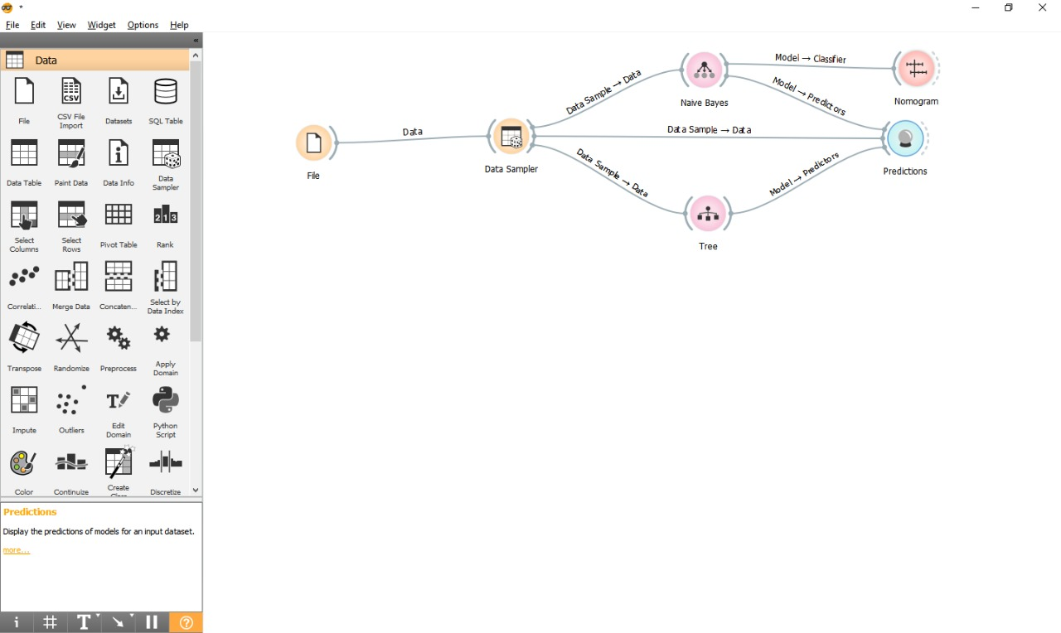

Double click on the prediction and following list will be displayed.

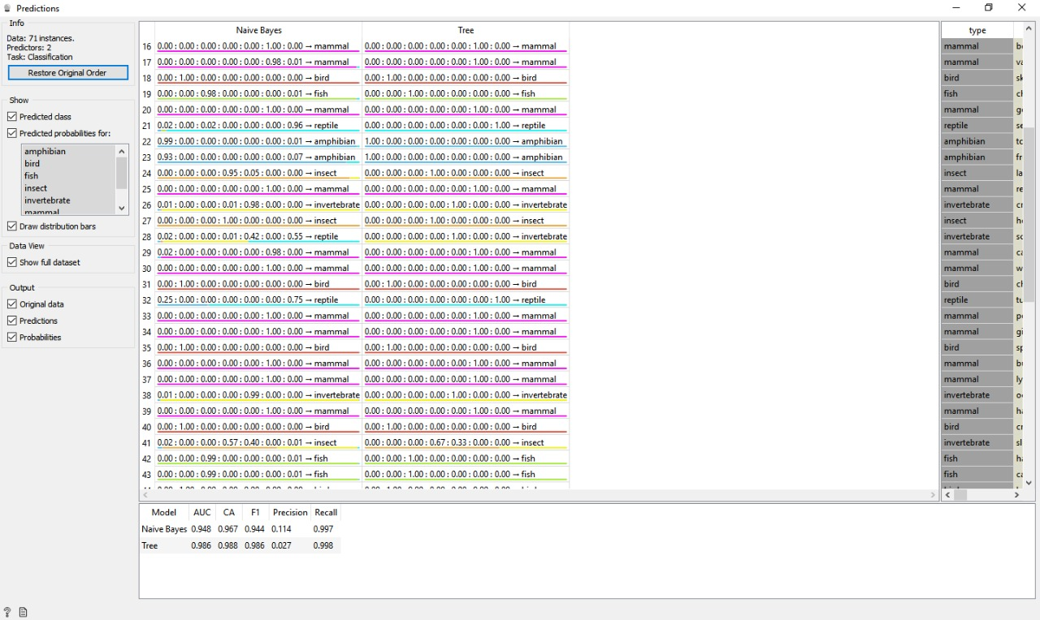

Afterwards select prediction and drag and create linear projection.

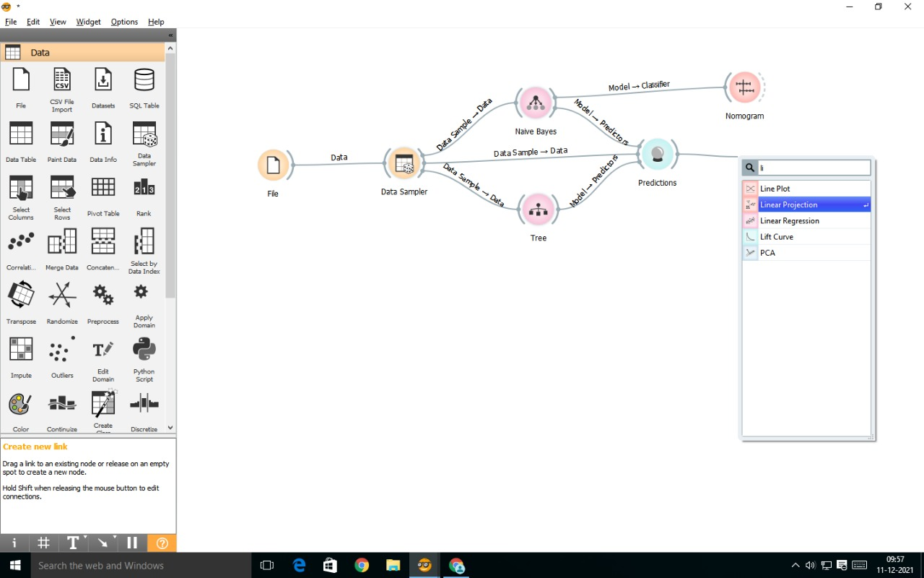

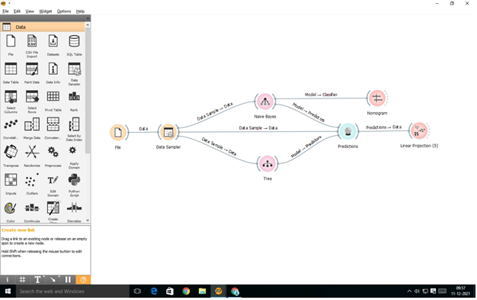

Double Click on Linear Projection and you can see the different classes of zoo animal.

